ZH-5W4 LED Display Controller
Specification

Hardware:
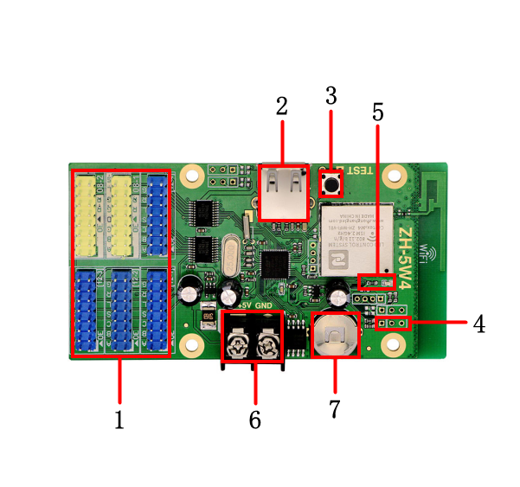

Item | Interface Name | Description
1 | Hub Port | Connect hub board
2 | USB Port | USB Port
3 | Multi-function Button | 1.Test LED panel  2.Reset to defaults
4 | Sensor Port | Connect temperature sensor
5 | 5V Power Indicator | Indicating power state
6 | 5V Power Port | Voltage range support 3.2V-5.5V
7 | RTC Button Battery | RTC battery, Voltage 3V

Parameter:

PC Software | LED Control System V5.1.15
Mobile Phone App | ZH Mobile
Pixel | 32*1280 64*640
Hub Port | 4*hub12 2*hub08
Communication Port | WIFI+USB
Support Module Type | All kinds of single/dual color LED display modules
Software Function | Multi-language/Multi-program/Multi-partition
Program Number | 65536 programs, 16 partitions for each program.
Play Type | Text, Graphic, Animation, Time, Clock, Timer, Temperature.
Running Side | Over 10 kinds of running sides, support single partition running side.
Clock Display | Digital clock, Analog clock, Positive timing, Negative timing.
Memory | 2 MByte
Sensor | Temperature sensor
Sensor Model | DS18B20
Brightness Adjustment | 15 levels brightness, automatically adjust by time.
Remote Switch | Support timing turn on/off, turn on/off by software.
Working Voltage | 3.2V-5.5V
Max Power | ≤0.5W
Working Temperature | -30℃~70℃
Secondary Development | Offer development protocol

Sensor Connection Diagram:



